**CHATBOT DEPLOYMENT WITH IBM CLOUD WATSON ASSISTANT**

**DEVELOPMENT PART 2:**

Integrating the chatbot with Facebook Messenger and Slack using respective APIs.

Initially go to IBM and login and then go to the already existing Watson instance and then open it and launch the assistance. It shows already existence bot that we created in the before phase open the home page in it and then start connecting the channels.

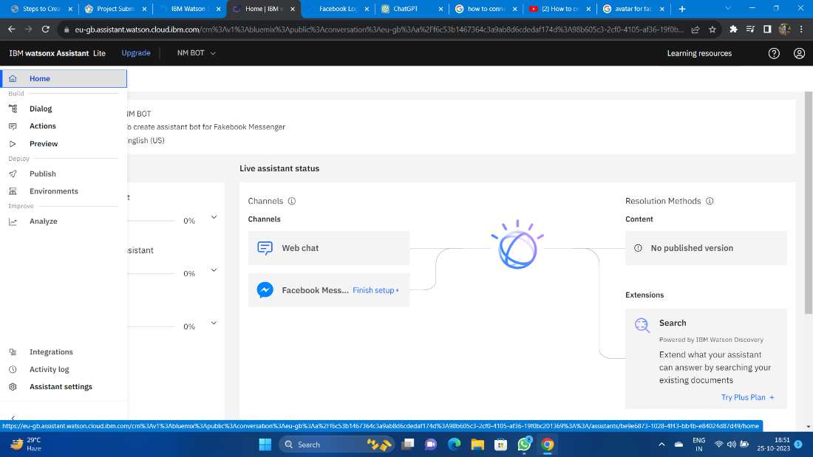

**Step 1:** Create a Facebook Page

Log in to your Facebook account.

Go to Facebook's Create a Page and follow the steps to create a Facebook Page. This Page will be used to host your chatbot.

**Step 2:** Set Up a Facebook App

Go to the Facebook for Developers website.

Create a new app by clicking on "My Apps" and then "Create App."

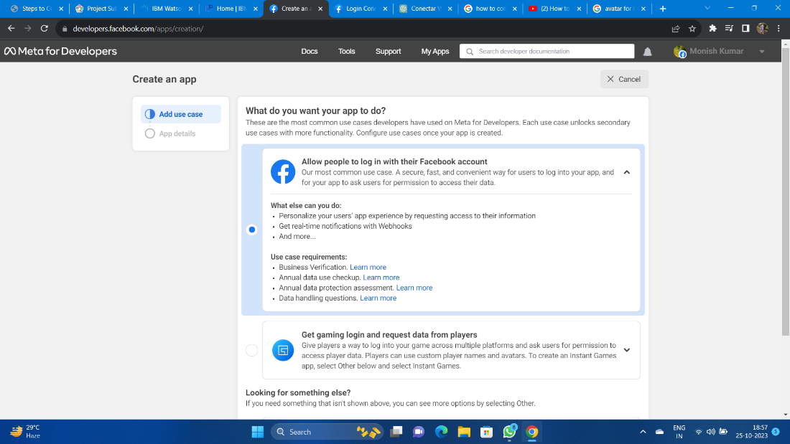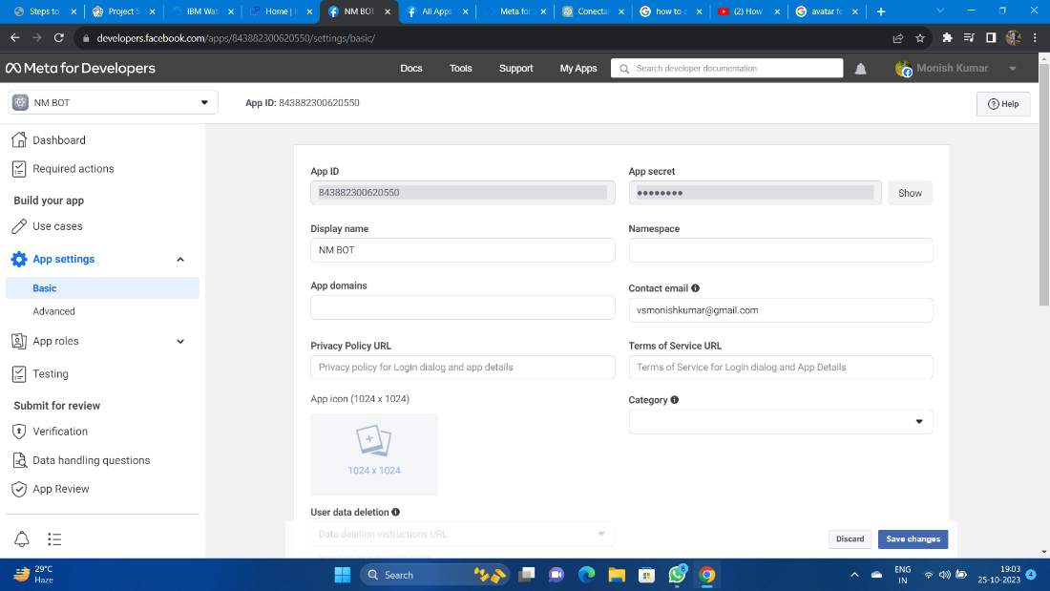

**Step 3:** Configure the Facebook App for Messenger

In your Facebook App dashboard:

a. Go to the "Messenger" section.

b. Under "Access Tokens," generate a Page Access Token. You'll need this token to connect your Watson Assistant to Facebook Messenger.

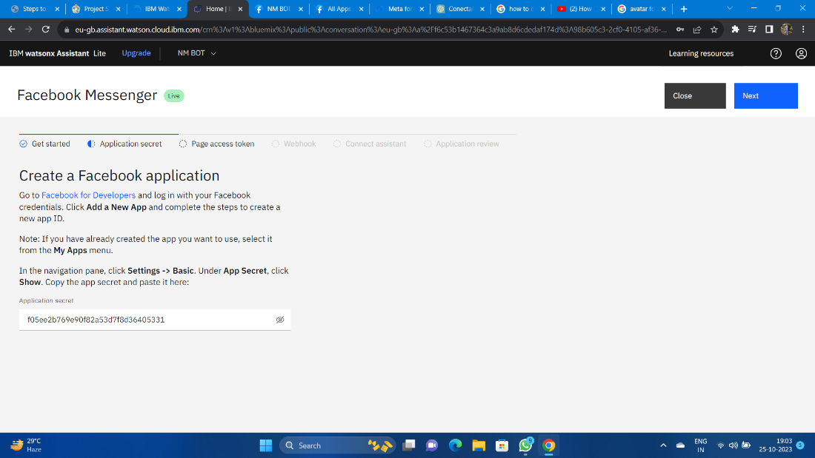

**Step 4:** Create or Access IBM Watson Assistant

If you don't have an instance of IBM Watson Assistant, you can create one on the IBM Cloud.

**Step 5:** Configure Watson Assistant

In your IBM Watson Assistant instance:

a. Create a new assistant or use an existing one.

b. Configure your assistant by adding intents, entities, and dialog flows that suit your chatbot's purpose.

(Note: Step4 and Step5 already completed in phase 3 )

**Step 6:** Integrate Watson Assistant with Facebook Messenger

In the Watson Assistant Dashboard:

a. Go to the "Skills" section.

b. Add a new skill or use an existing one.

c. In the skill settings, go to the "Integrations" tab.

d. Click on "Facebook Messenger."

**Step 7:** Set Up the Webhook

In the Watson Assistant integration settings for Facebook Messenger:

a. Enter the Facebook Page Access Token you obtained in Step 3.

b. Specify the Webhook URL. This URL should be the same as the callback URL you set up in the Facebook App's Webhook settings.

c. Save the changes.

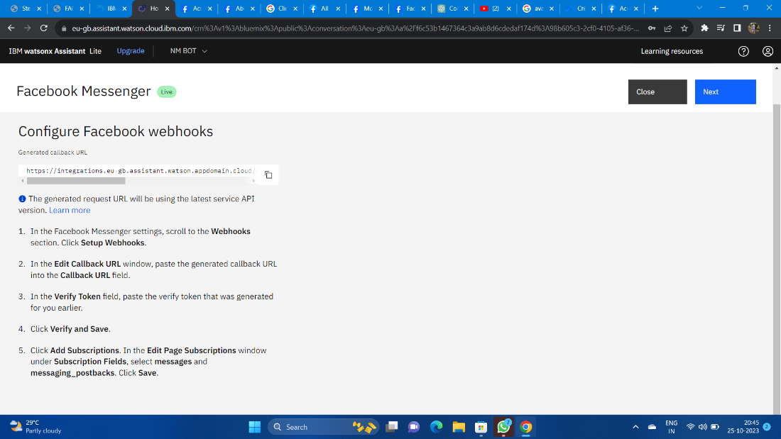

Step 8: Subscribe to the Facebook Webhook

In the Facebook App settings:

a. In the "Webhooks" section, click on "Edit Subscription."

b. Select the Facebook Page you created in Step 1.

c. Subscribe your Page to the webhook events.

After competing all the steps complete it and click finish the connection now your bot is connected with the face book messenger